High-Level Product Requirements Document (PRD) – Supplier Information Management (SIM)

1. Product Overview
FCL requires a modern Supplier Information Management (SIM) solution that centralizes supplier data, improves onboarding, applies commodity-driven governance, reduces manual processes, and supports the entire Source-to-Pay lifecycle.
The SIM system must enable:
- Supplier creation (internal + external self-registration)
- Tiered onboarding workflows (Tier 1–3)
- Commodity-driven questionnaires, documents, and approvals
- Automated risk scoring & compliance checks
- Supplier profile management
- Integrations (JDE, D&B/LexisNexis, Power BI, AdobeSign, Entra ID)
- Document management with expiry rules
- Supplier updates, revalidations, and deactivation
This PRD outlines core functions necessary for build + testing cycles.
2. Core Functionalities (High-Level)
2.1 Supplier Creation
Internal Users must be able to:
- Create supplier requests with mandatory fields: Name, Email, Country, Commodity, Reason for request, Level, Spend estimate.
- Trigger automatic duplicate detection (name, Tax ID, email domain, banking info).
- View and act on duplicate results (use existing, request update, override with justification).
- Auto-assign supplier onboarding tier (Tier 1–3).
- Generate supplier invitation email.
- Track supplier onboarding status in dashboard.
Functional Tests Required
- Field validation
- Duplicate detection accuracy
- Tier assignment logic
- Invite generation
- Dashboard visibility
2.2 Supplier Self-Registration
Suppliers must be able to:
- Register via portal
- Complete progressive onboarding steps
- Upload documents
- Receive notifications
- Save & resume
- Pass duplicate detection
- Follow commodity-driven instructions
Tests Needed
- Self-registration UI
- Mobile responsiveness
- Progress bar
- Auto-save
- Commodity-driven content

3. Tiered Onboarding Framework
Tier 1 – Basic Supplier
- Minimal data
- No risk questionnaire
- Optional COI
- Single-step approval
Tier 2 – Standard Supplier
- Company info + tax documents
- Commodity-driven question sets
- Optional COI
- 2-step approval (SIM Admin → Procurement Manager)
Tier 3 – Strategic/High Risk
- Full questionnaire
- Mandatory COI / Safety / ESG
- External screening
- Multi-level approvals
Tests Required
- Correct tier assignment based on commodity + spend + supplier type
- Correct document requirements per tier
- Correct approval workflow execution

4. Commodity-Driven Logic
Commodity file mapping must drive:
- Required documents
- Required questionnaire sections
- Approval routing
- Tier selection
- Risk scoring
- Supplier segmentation
Tests Required
- Commodity selection validation
- Correct document/questionnaire triggers
- Correct routing based on commodity
- Tier reassignment when commodity changes

5. Document Management Requirements
The system must support:
- Mandatory/optional documents
- Commodity-based document rules
- Expiry tracking + reminder notifications
- Document preview, versioning, rejection, resubmission
- Max file size: 100MB
- Storage encryption
Tests Needed
- Expiry rule triggering
- Reminder notifications
- Document approval/rejection workflows
- Version control

6. Risk & Compliance Requirements
System must include:
- Automated risk score calculation (0–100)
- Low/Medium/High classification
- External screening integration
- Sanctions blocking logic
- Annual supplier revalidation
- Auto-updated risk when commodity/documents change
Tests Required
- End-to-end screening
- Sanctions “block” scenario
- Risk score accuracy
- Revalidation workflow

7. Supplier Profile (Supplier 360)
Supplier profile must include tabs for:
- General Info
- Locations
- Contacts
- Commodities
- Documents
- Risk
- Contracts
- Sourcing Events
- Notes & Messages
- Audit Trail
Tests Required
- Profile completeness
- Role-based view restrictions
- Audit tracking
- Data sync accuracy

8. Supplier Updates & Change Requests
Suppliers & buyers must be able to request updates to:
- Banking
- Address
- Contacts
- Insurance/COI
- Commodity
- ESG information
Rules:
- Banking updates = Finance approval
- Commodity change triggers tier reassessment
- All updates logged
Tests Required
- Field-level workflow
- Approval routing
- JDE sync after approval

9. Deactivation & Reactivation
Must support:
- Deactivation with justification
- Check for open events/contracts
- Approval routing
- Reactivation requiring updated documents & risk checks
Tests Required
- Validation of blocking rules
- Deactivation approval flow
- Reactivation logic

10. Workflows & Approvals
System must support:
- Tier-based workflows
- Commodity-based workflows
- Risk-based workflows
- Delegation of Authority (DOA)
- Escalations
- Resume/pause logic when supplier updates
Tests Required
- All workflow routes
- Conditional routing
- Escalation triggers

11. Integrations (High-Level Functional Requirements)
INTEGRATION 1 — JDE
- Sync supplier name, address, ID, status, tax, banking, commodities
- Real-time on activation
- Nightly commodity sync
INTEGRATION 2 — Screening Providers
- D&B / LexisNexis for financial + sanctions
- Risk engine updates
INTEGRATION 3 — AdobeSign
- Banking updates
- COI/Compliance signature
INTEGRATION 4 — Power BI
- Daily export of supplier master, documents, risk, SLA
INTEGRATION 5 — Entra ID
- SSO internal
- B2B guest access for suppliers
Tests Required
- Data field mapping validation
- Trigger tests
- Error handling

12. Reporting & Dashboards
System requires dashboards for:
- Supplier onboarding SLA
- Risk
- Document compliance
- Commodity mapping
- Data quality
- Workflow performance
Tests Required
- Data refresh
- Filter logic
- SLA calculations

13. Non-Functional Requirements (High-Level)
Area | Requirements
Performance | Page load < 3 seconds
Availability | 99.9% uptime
Security | AES-256 encryption, RBAC, SSO
Privacy | PIPEDA, GDPR
Scalability | 10,000+ suppliers, 500,000+ documents
Accessibility | WCAG 2.1
Monitoring | API/integration monitoring
Backup | Daily + weekly full backups
Tests Required
- Load testing
- SSO test
- Role-based access

14. Test Scenarios (For QA Planning)
Below is a high-level list of mandatory test scenarios.
A. Supplier Creation
- New supplier → Tier 1/2/3
- Duplicate detection
- Workflow routing
B. Supplier Self-Registration
- Commodity-driven forms
- Auto-save
- Document upload
C. Onboarding Workflows
- Tier 1 simple
- Tier 2 moderate
- Tier 3 high-risk
D. Document Governance
- Expired COI blocks supplier
- Rejection & resubmission
E. Risk & Compliance
- Sanctions match
- High-risk routing
- Risk score recalculation
F. Supplier Profile
- Role-based views
- Data sync to JDE
G. Integrations
- JDE vendor creation
- D&B screening
- Power BI export
H. Supplier Updates
- Banking update with approval
- Commodity change triggers new tier
- Document replacement

15. Go-Live Readiness (High-Level)
The following must be complete before launch:
- Role-based training
- Commodity rules activated
- Test cycle completed
- JDE integration validated
- Supplier portal tested
- Risk engine calibrated
- All workflows activated
- Dashboard validation

16. Wireframe Mockups for SIM Homepage, Registration and Onboarding
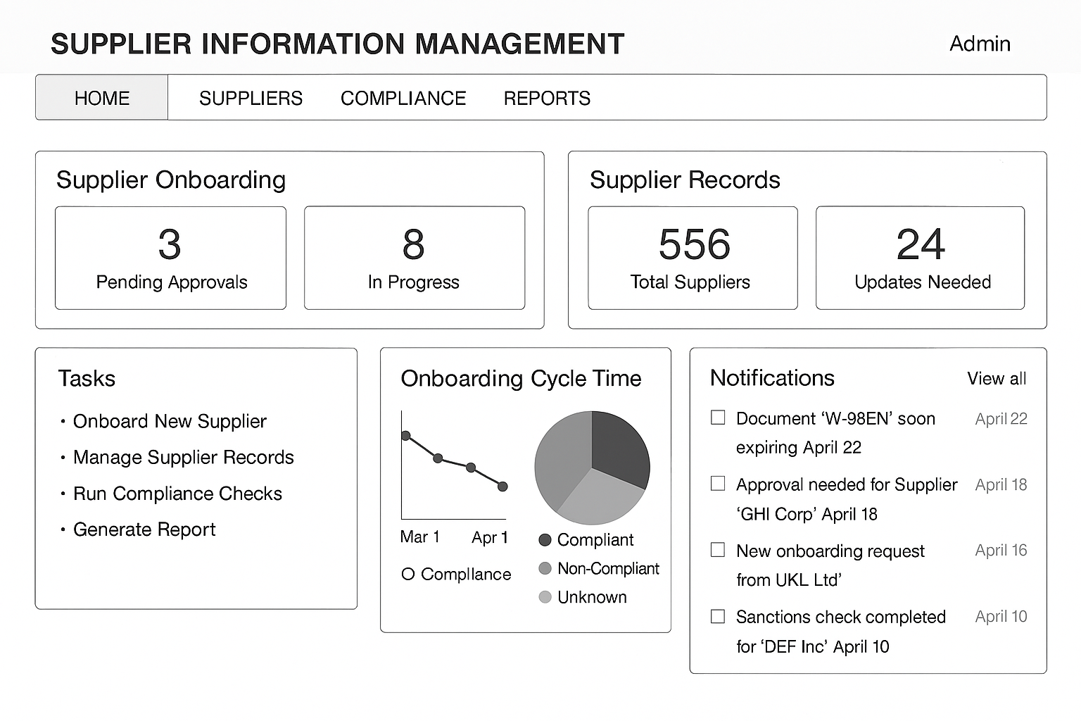

Supplier Registration – Short Form
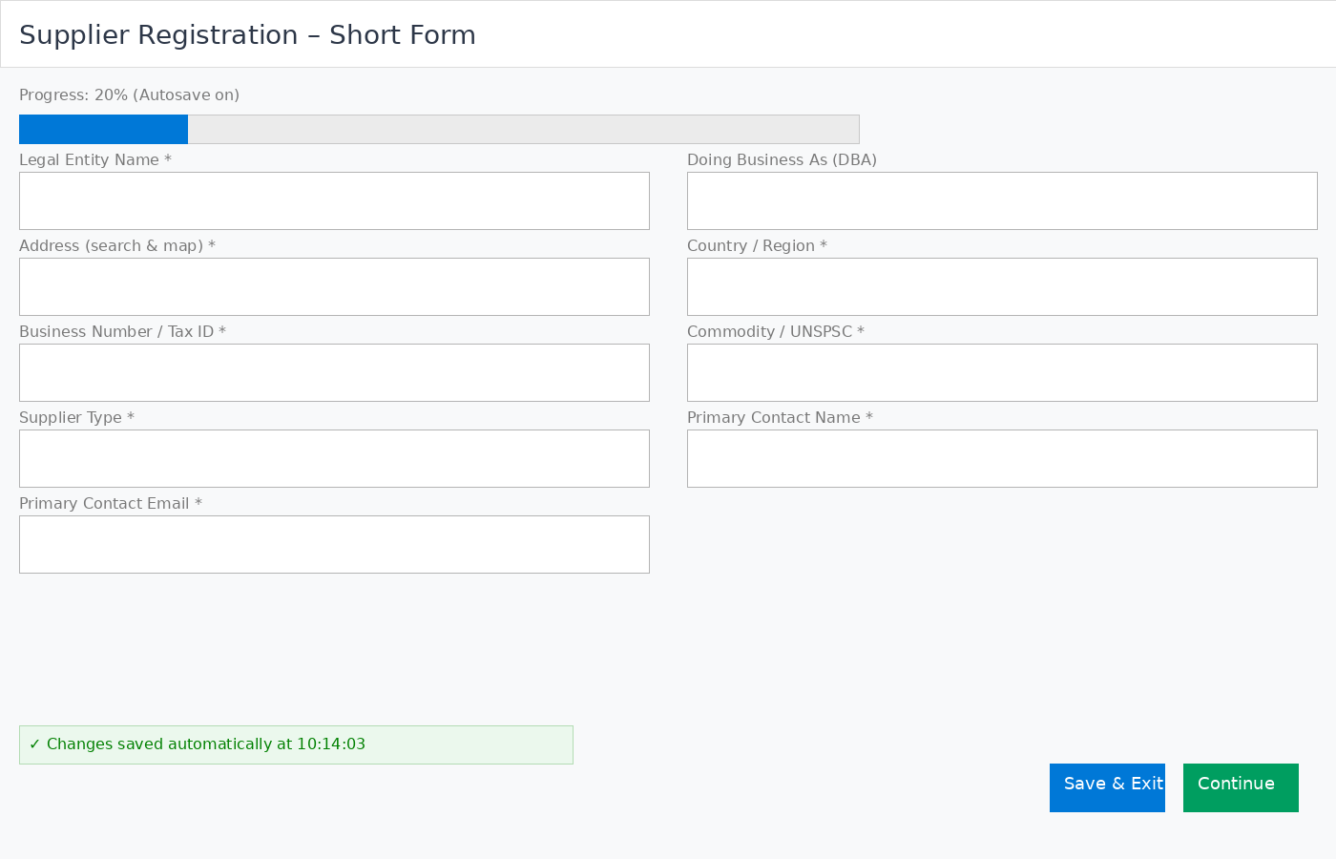

Onboarding – Requirements & Approvals (alerts & progress)
